**EXERCISE 3.4**

**Q1. Find the conjugate of the following**

**SOLUTION**

**SOLUTION**

**SOLUTION**

**SOLUTION**

**SOLUTION**

**SOLUTION**

**SOLUTION**

**SOLUTION**

**Q2. Rationalize the denominator of the following**

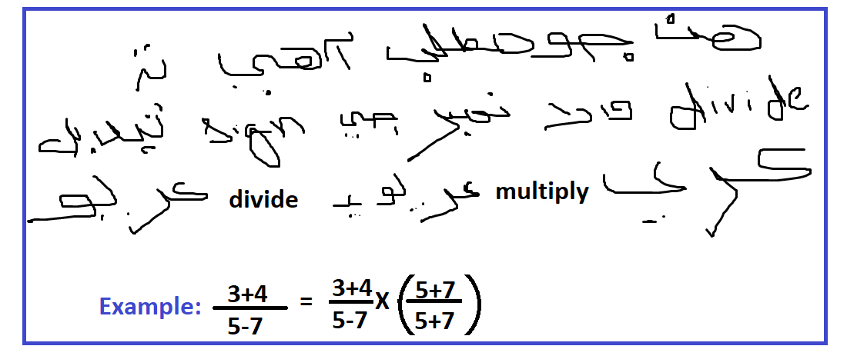

**SOLUTION**

**(**

**SOLUTION**

**(**

**SOLUTION**

**(**

**SOLUTION**

**(**

**SOLUTION**

**(**

**AND**

**(**

**SOLUTION**

**(**

**AND**

**(**

**SOLUTION**

**(**

**SOLUTION**

**(**

**AND**

**(**

**SOLUTION**

**(**

**SOLUTION**

**(**

**Q3.**

**SOLUTION**

(

**SOLUTION**

**SOLUTION**

(

Put values in equation (1)

**Next**

(

Put values in equation (1)

**Next**

Put values in equation (1)

(

Put values in equation (2)

**Next**

Put values in equation (1)

(

Put values in equation (2)

**Next**

Put values in equation (1)

Put values in equation (2)

(

Put values in equation (3)

**Q3.**

**SOLUTION**

(

Put in Equation (1)

**SOLUTION**

(

Put in Equation (1)

**SOLUTION**

(

Put in Equation (1)

**SOLUTION**

(

Put in Equation (1)

**SOLUTION**

(

Put in Equation (1)

**SOLUTION**

(

Put in Equation (1)